Practical-3

**Name:-Vishwajit kate**

**Reg. No:-2020BIT011**

* Write C/C++ code to implement concept of
* Searching Algorithm (Any 3
* Sorting Algorithm (Any 3)
* 1)Searching Algorithm
  + > Program: Linear Search 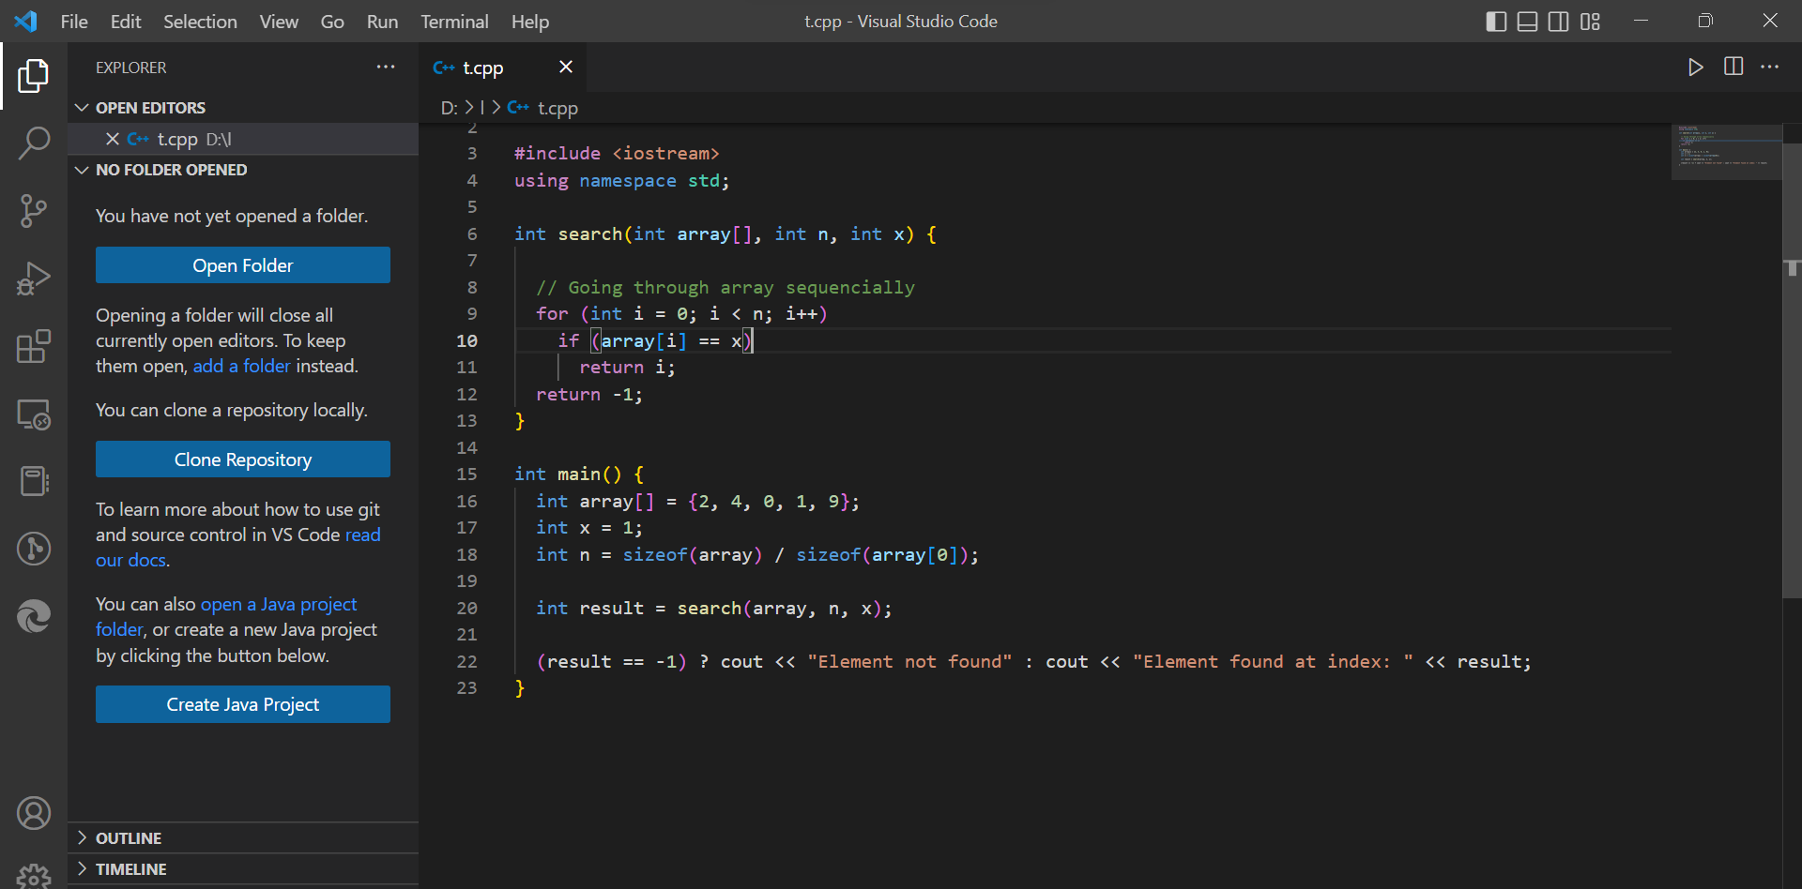

Output:

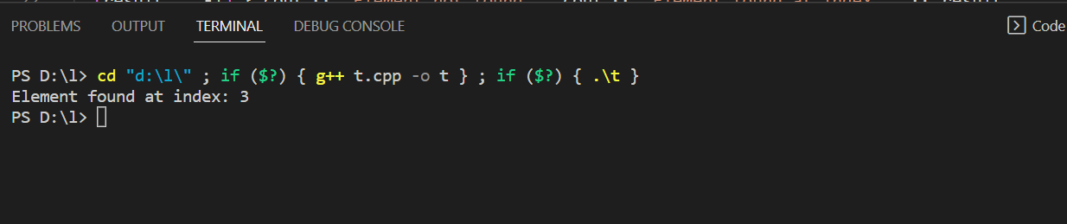

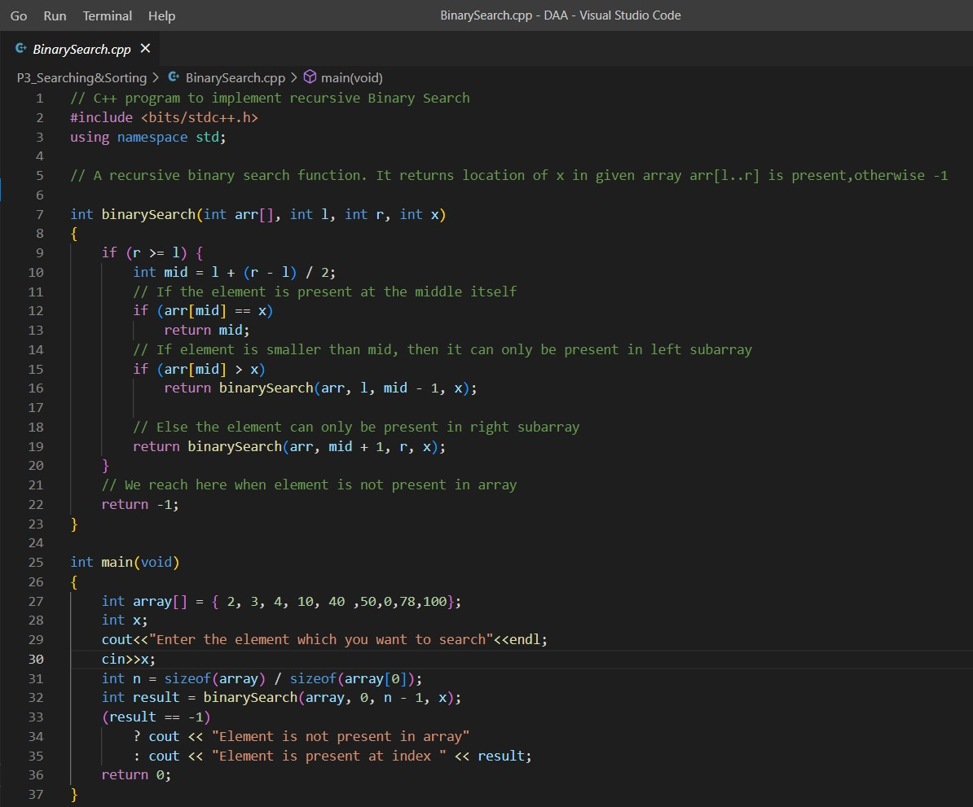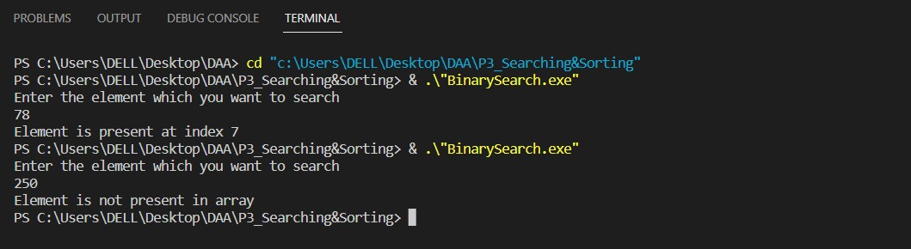

* + >Program: Binary Search

Output:

* + >Program : Meta Binary Search

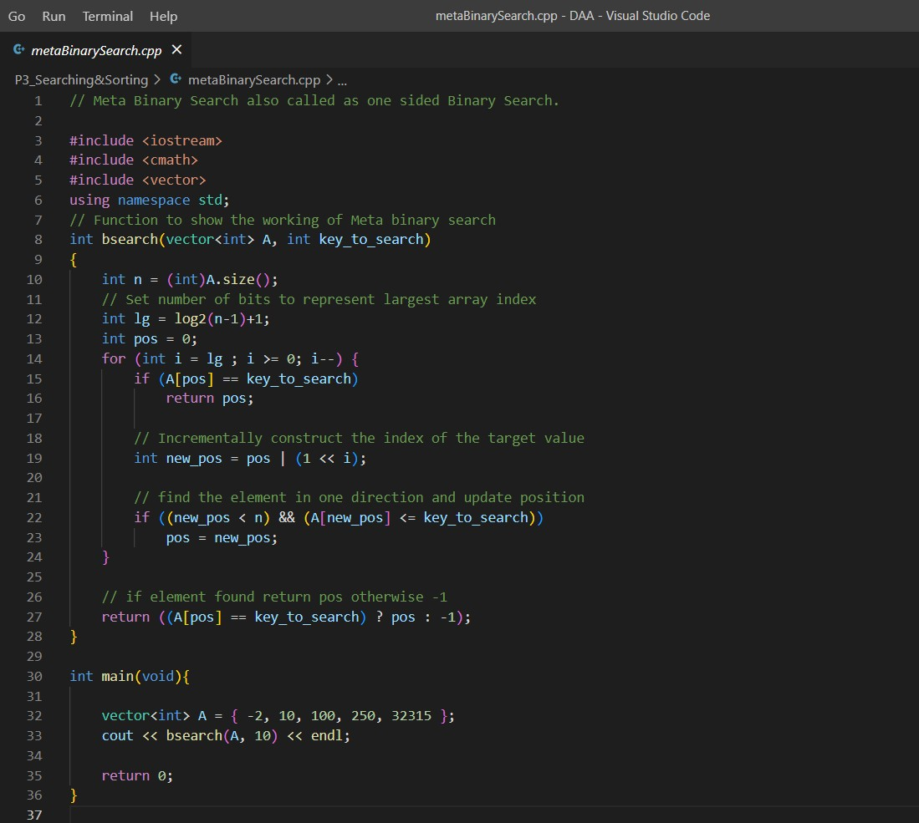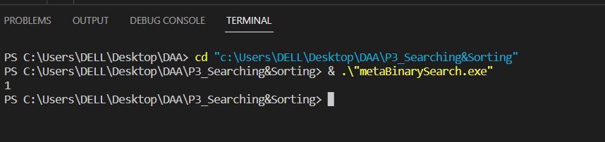

Output:

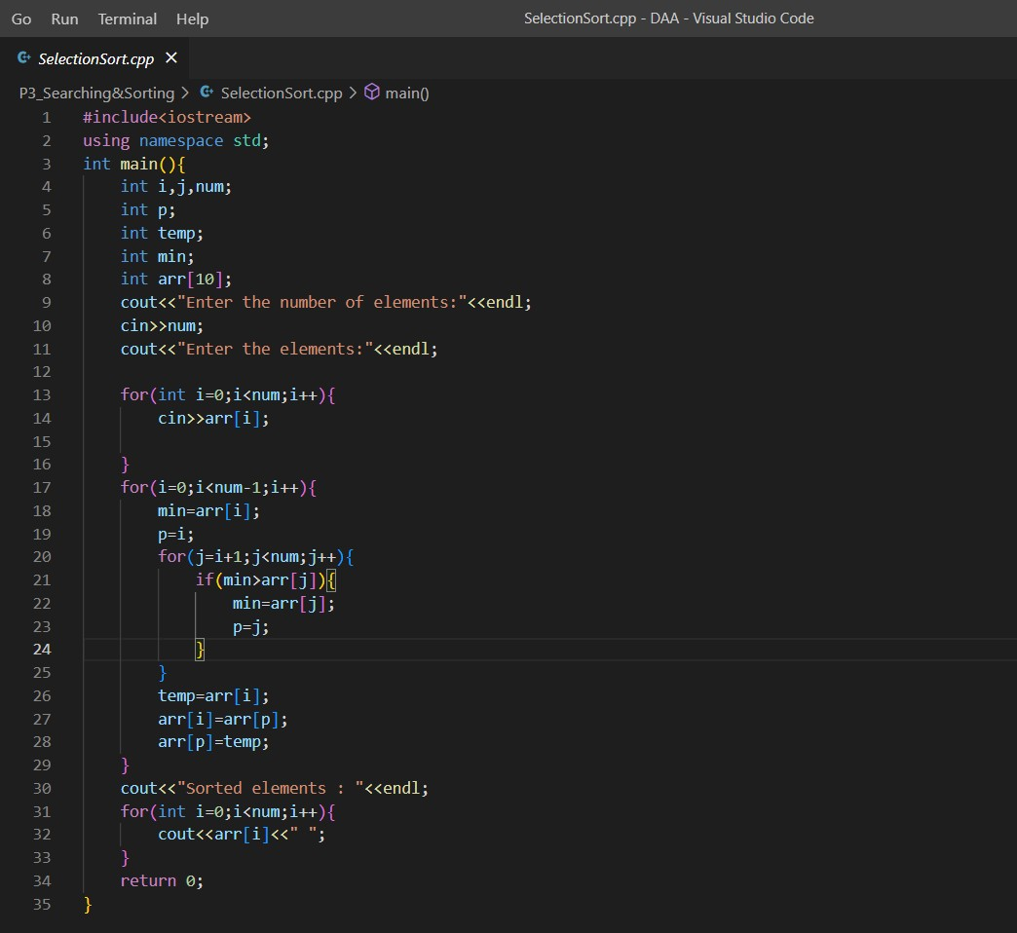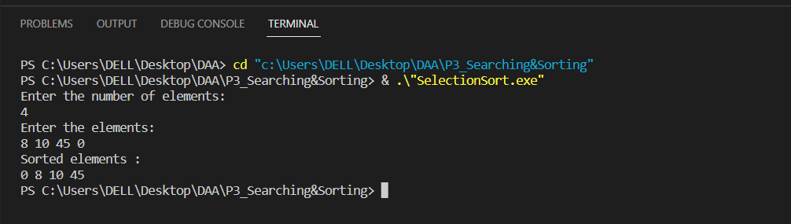

* + Program : Selection Sort

Output:

* Program :Bubble Sort

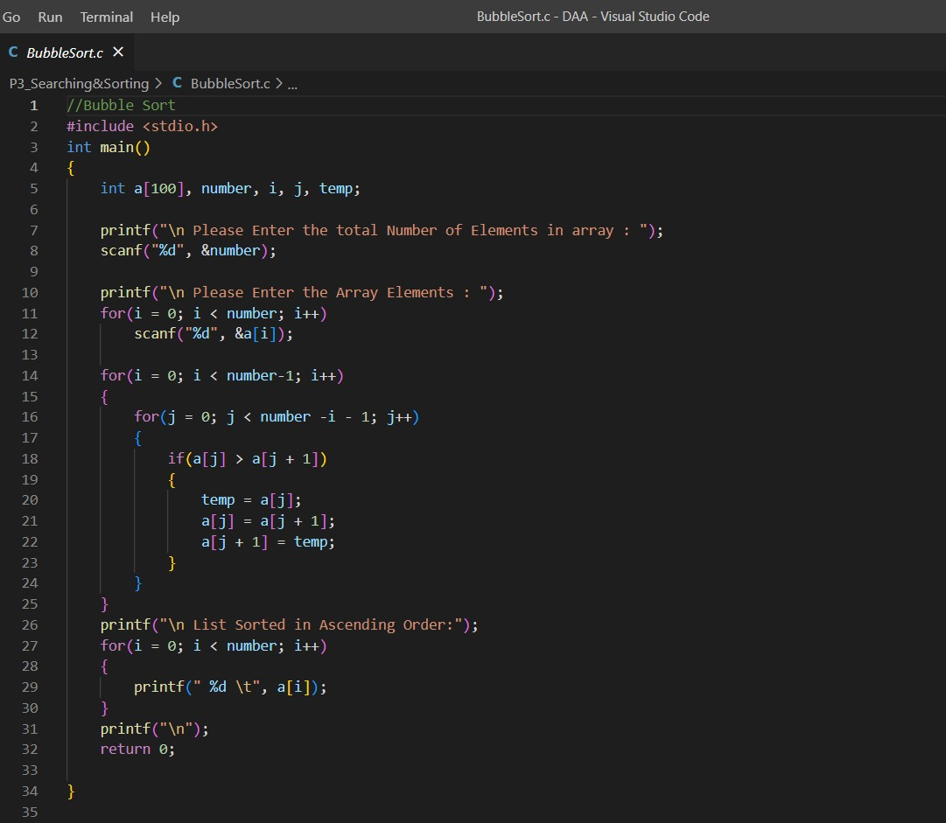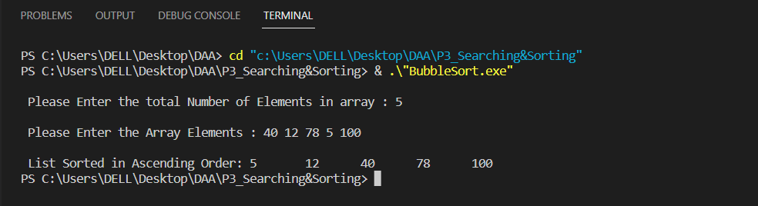

Output:

* + Program : Insertion Sort

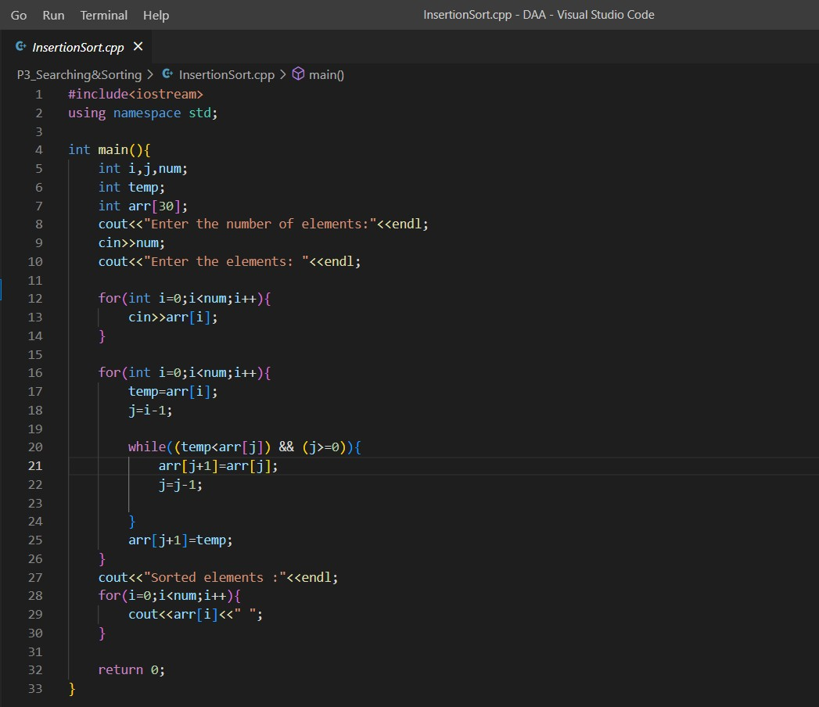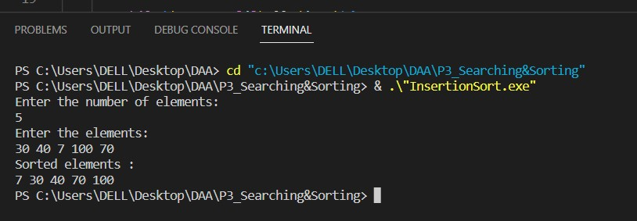

Output: